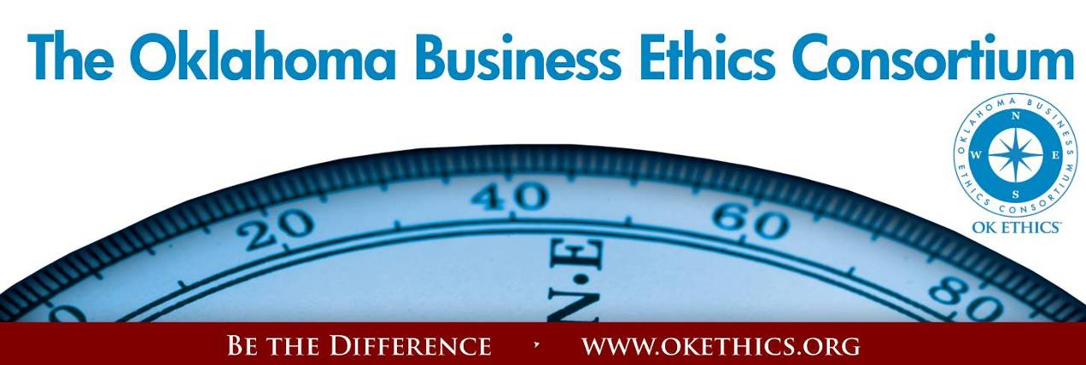
Agenda – October 10, 2012
- Membership Drive – Garyl Geist, Chief Operating Officer, Oklahoma Asthma
& Allergy Clinic; President, OK Ethics (State) Board of Directors

KICKING OFF OUR TENTH YEAR PROMOTING OKLAHOMA VALUES OF INTEGRITY AT WORK!
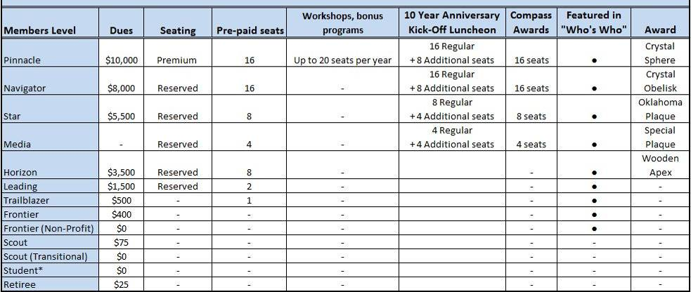

II. Book Signing immediately following program; Make $10 checks payable to Character First;
credit cards accepted, too.
III. Student/Educator Initiatives – Bob Byrne, (Retired) Boeing, Former President, OK Ethics Foundation
STUDENT ETHICS CHALLENGE
SATURDAY, OCTOBER 13 – UNIVERSITY OF OKLAHOMA: SEE VOLUNTEERS & TEAMS ON PAGES 2 & 3
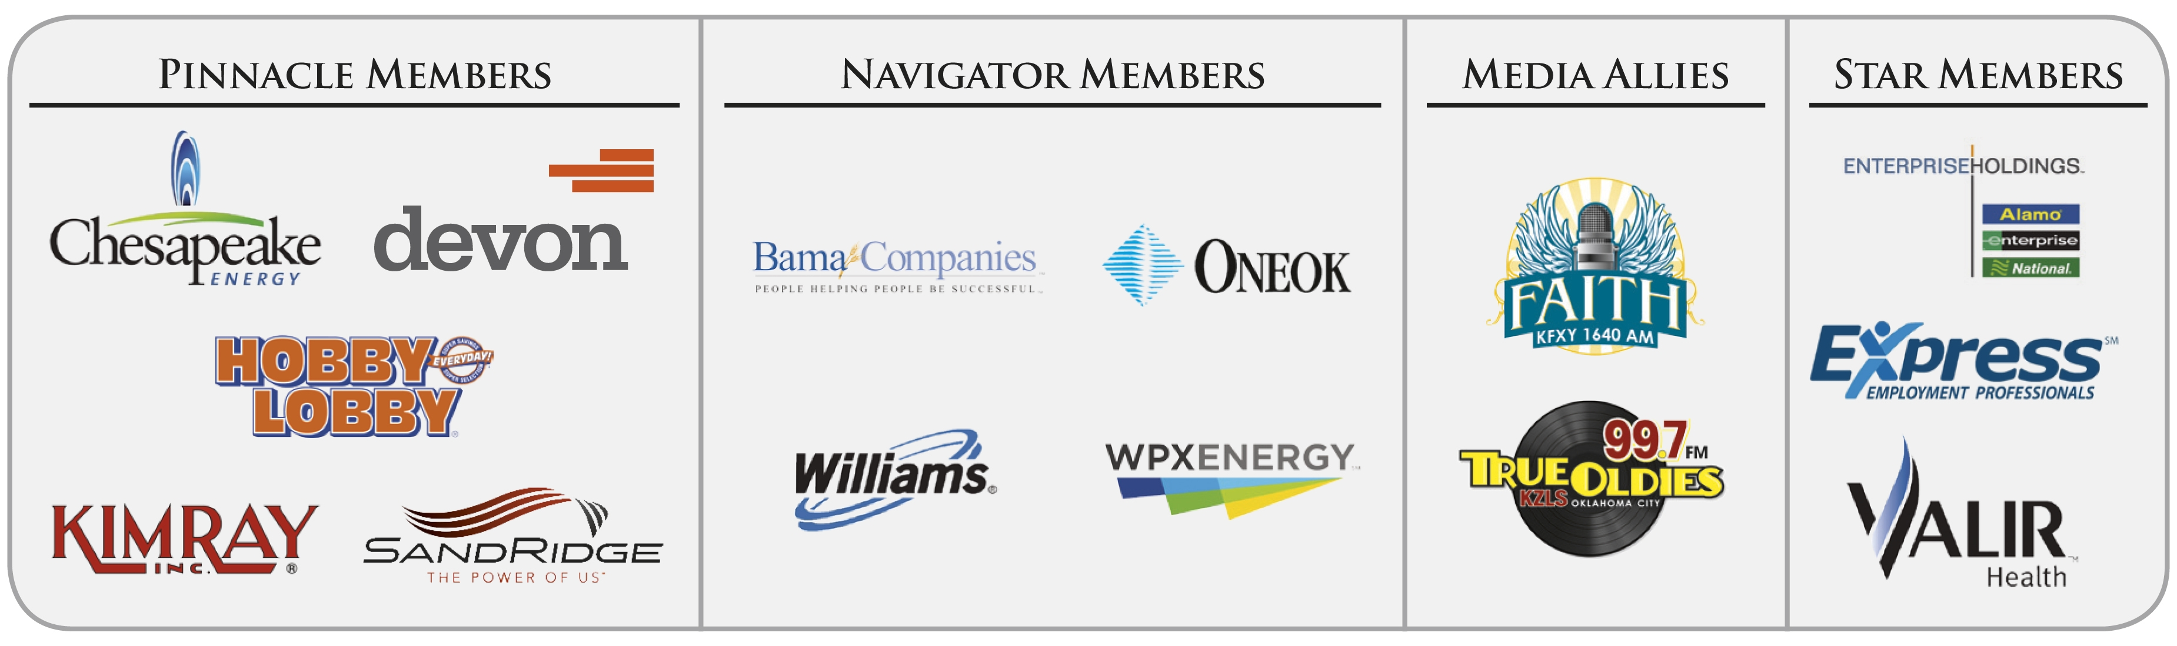
● 16 teams registered; 32 judges; 6 corporate moderators
● Campuses: Cameron, OBU, OCU, OSU, OU, Oklahoma Christian, SNU, TU, UCO, and University of Science & Arts

IV .VOLUNTEER RECOGNITION:

STATEWIDE STUDENT ETHICS CHALLENGE:
Organizers & OK Ethics Board Members*:
Shannon Hiebert (OK Ethics Foundation President), Vice President of Human Resources, Enterprise Holdings

Judges:

Reverend Ray Belford, Senior Pastor, First Christian Church
Bill Blew, Former Judge, President of The Olive Branch
Reverend Linda Brinkworth, Pastor Care Ministry, St. Luke's United Methodist Church
*Bob Byrne, Retired, The Boeing Company
Tommy Campbell, Tax Partner, PricewaterhouseCoopers LLC (Tulsa)
Ginger Castleberry, Occupational Therapist/ Quality Assurance and Risk Manager, Valir Health
Young Chappell, Systems Engineer, The Boeing Company
Keith Chappell, Engineering Manager, The Boeing Company
Sue Chase, Human Resources, GE Oil and Gas
* Lynn Flinn, President, The Rowland Group (Tulsa)
* Pam Fountain, President, Principal Technologies
* Garyl Geist, Chief Operating Office, Oklahoma Allergy Clinic
Shad Glass, Director of Human Resources, Kimray, Inc.
Gary Huneryager, Vice President, Internal Audit, OG&E Energy
Dr. Philip Hyde, Clinical Psychologist, Oklahoma Psychological Center
* Joy LaBar, Vice President, Internal Audit, SandRidge Energy, Inc.
Dr. Cappy Leland, CEO/ Founder, Performance Dashboard
Donna Miller, Vice President, Human Resources, Chaparral Energy
Brian Nagle, Google Data Center, Assistant Operation Manager (Tulsa)
* Michael Oonk, Vice President, Commercial Lending, American Bank and Trust (Tulsa)
Bridget Poputa-Clean, Sales Management Coordinator (former Student Ethics
Champ),Coppermark Bank
Becky Robinson, Vice President, Risk Management, Hobby Lobby
Ben T. Robinson, Former General, CEO of Sentry One LLC
Kim Rolston, Esq., General Counsel, W&W Steele and AFCO Steel
Reverend Robert, Rose, Senior Minister, Chapel Hill United Methodist Church
Tonya Salazar-Purvine, Chief Legal Officer and Compliance Officer, Valir Health
* Colin Schoonover, Manager/Pipeline Systems/Engineering Services, Oklahoma Natural Gas
Tony A. Scott, Esq., CPA, CFO, Oklahoma Heritage Association
Edith Steele, Owner, Secure Evaluations and Consulting
Joe Walker, Controller, Wilbanks Securities, Inc.
David Winfrey, Corporate Recruiting Team, Chesapeake Energy Corporation
*Signifies Board member

Master Scorekeeper:
Christopher M. Caldwell, CPA

Moderators:

Stephanie Beauchamp, Oklahoma State Regents
for Higher Education
Michael Buckley, Total Life Designs
Beth Chandler, ONEOK
Mel Inman, ONEOK
Lauren Maxey, ONEOK
Kim Whyburn, Devon Energy
University of Oklahoma Students & Faculty

STATEWIDE STUDENT ETHICS CHALLENGE (Continued):

Teams & Advisors:


Tracy Manly, Professor, University of Tulsa
Dr. Rich Rudebock, Associate Professor, Oklahoma Baptist University
Dr. Steve Ellis, Associate Professor, University of Oklahoma
John K. Masters, Associate Professor, Cameron University
Dr. Barbara Crandall, Professor, Oklahoma City University
Dr. Katherene Terrell, Professor, University of Central Oklahoma
Jeff Simmons, Associate Professor, Oklahoma Christian University
Wendi Ferrell, Instructor in Business Administration, University of Science & Arts of Oklahoma
Dr. Andrew Urich, Associate Professor, Oklahoma State University
Cindy Powell, Professor, Southern Nazarene University

VOLUNTEERS FOR TODAY’S EVENT:

Don’t forget to register for Volunteer & Member Awards – November 15 – Oklahoma Golf & Country Club
OK Ethics relies primarily on volunteers to achieve the organization’s successful pursuit of Oklahoma’s values of integrity at work. It takes leadership and teamwork to host these exciting events!

Special Efforts Made By:
Accounts Receivable Reconciliation: Susan Pate, Stinnett & Associates
Agendas: Metro Technology Centers
Book Sales: Character First
CPE’s: Michael Mount, CPA,
Oklahoma Accountancy Board
Facilities & Logistics: Jamie Potter, Eide Bailly
Name tags: Anna Rosenthal, Accounting Principals
Member Care Coordinator: Jalisha Petties, Accounting Principals

Registration Team: These dependable individuals show up every month to diligently record our guests’ attendance and handle the collection of fees:
- Mark Neumeister, Chairperson; D. R. Payne & Associates
- Joe Walker, Chairperson (Prepaid members); Wilbanks Security
Team Members:
  - Mary Vaughn, CPA, JMA Energy
  - Marvinette Ponder, Devon Energy
Ambassador Team: These friendly people welcome our guests each month and assist in helping them locate seats. They also arrive early to help distribute agendas and assist with name tags.
Team Leaders:
Brent Martens (Team Leader), Accounting Principals
Linda Streun (Ambassador Chairperson), Ideal Homes of Norman
Team Members:

- Scott Harris, Oklahoma Baptist University
- Wayne Hart, Legal Shield
- Jenny Hatton, Boeing
- Tammy McKeever, Enterprise Holdings
- Connie Root, Walker Companies
- Lynn Willis, Metro Technology Centers

Help spread the word:
Please post Upcoming Events on your company’s bulletin board.

- Upcoming Events: Oklahoma City Chapter Shannon Warren, Founder, OK Ethics
TUNE IN! Our own Bob Byrne and Shirley Mears featured on the morning drive for True Oldies Channel FM 99.7 – Tune in between 7:00 and 8:00 a.m. to learn more about Oklahoma’s legacy! Also, hear interviews with speakers thanks to Champlin Broadcasting!

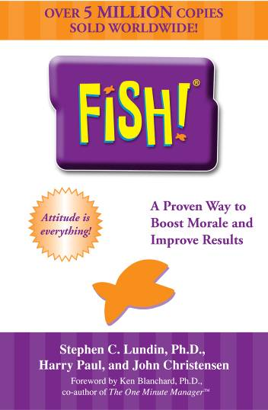
November 15, 2012 - VOLUNTEER & MEMBER RECOGNITION
LUNCHEON - OKLAHOMA GOLF & COUNTRY CLUB
Fish! and The Power of Ethics
presented by
Harry Paul, co-author Fish!
Presented by Harry the Fish! Guy; co-author of the best-selling book that creates fun at work while maintaining one’s integrity. With a Ph.D. in experience, Harry worked with Ken Blanchard and collaborated with Norman Vincent Peale on the launch of the book, The Power of Ethical Management. You will leave this session feeling invigorated and inspired!
A separate, special interactive morning session will be offered through the Peer Learning Network at Southern Nazarene University. Visit http://ziglarcenter.com/events for further information and registration.
Recommended for 1 CPE in Ethics
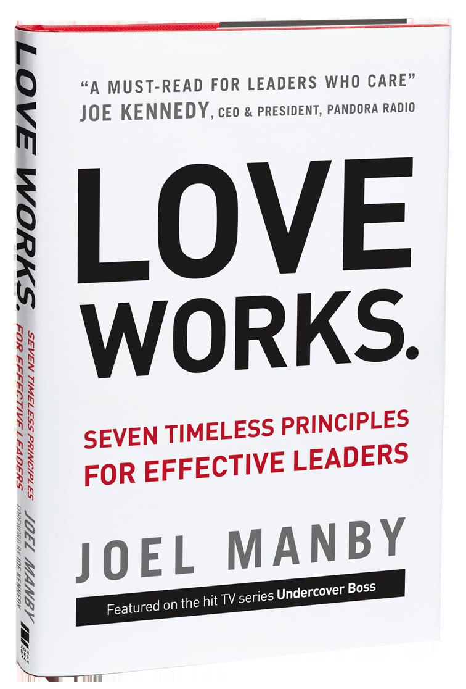
NOTE DATE CHANGE: Friday, December 7

Joel Manby, President and CEO, Herschend Family Entertainment Corporation,

You may have heard of Mr. Manby because he starred on the
CBS hit show Undercover Boss.
Manby and the employees of HFE moved millions of viewers across the world with their unique approach to leadership. He now shares the principles that make HFE successful in his new book, Love Works.

Manby has incorporated the definition of love the verb into the company’s existing organic culture to establish how leaders are to behave. He views love as a mode of thinking – one that has helped him deliver tangible results and position his company as the 9th largest themed attractions company in the world.

An expert on leadership and customer relations, he spent 20 years in the auto industry. Manby was a member of the start-up team for Saturn Corporation, followed by a successful career as CEO of Saab Automobile USA where sales increased by 67% and their J.D. Power Quality Rating improved from 30th to fifth in the industry.
Many thanks to our friends at Strata Leadership for making this happen!
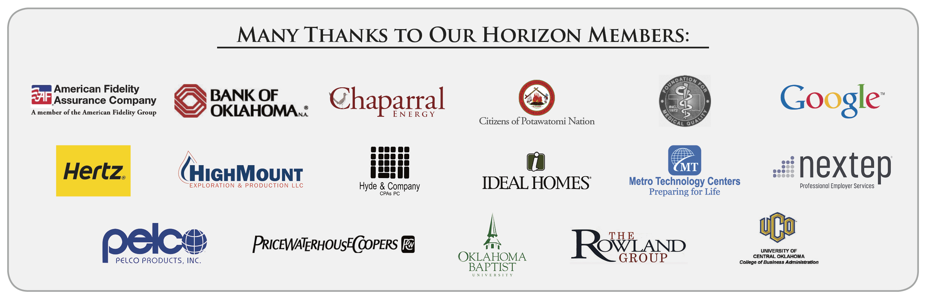
TULSA CHAPTER ACTIVITIES:
October 25
"A Champion's Perspective" presented by Jay Wilkinson, son of legendary OU Coach Bud Wilkinson
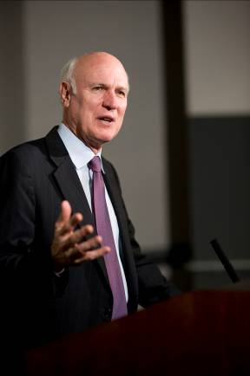
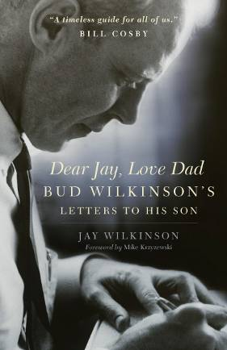

General Program Disclaimer:
Members of the Oklahoma Business Ethics Consortium frequently share information concerning various issues and developments that may have legal implications. The discussions, commentary, and handouts at Consortium meetings or presentations to other organizations are for general informational purposes only. They cover only some aspects of the subject topic, and do not constitute a complete legal analysis of the topic or how it might apply to any particular set of facts. Before taking any action based on information presented during a Consortium event, participants are encouraged to consult a qualified attorney. The observations and comments of presenters at Consortium meetings and networking are the views and opinions of the presenter and do not constitute the opinion or policies of the Consortium or any of its members. Presenters are respectfully requested to avoid profanity, preaching, politics, put-downs and self-promotion during their lectures
Interested in Receiving OK Ethics Monthly Meeting Notices?

OKC:
Contact Jalisha Petties, Member Care Coordinator
at (405) 889-0498 or via email okethics@yahoo.com

Interested in joining OK Ethics?

Contact Lynda Mobley, Vice President of Membership
Lynda.Mobley@oneok.com

REMINDER: PLEASE PICK UP CPE’S
AT CONCLUSION OF EVENT.

October 10, 2012 – Welcome back Tom Hill of Kimray, Inc.

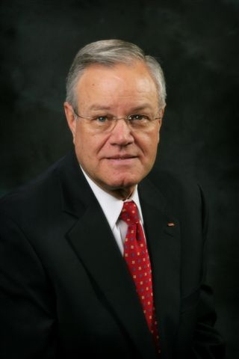
“Building Ethical Muscle”

Recommended for 1 CPE in Ethics
Mastering a skill takes practice.
Mr. Hill will provide insights on how to achieve optimal levels,
especially when confronted by those who don’t play by the same rules.

We are pleased to welcome OK Ethics first Executive Pilot Award recipient back to our podium. Since receiving this honor in April, 2010, Mr. Hill has authored a book Making Character First. Also, Kimray has been featured in the PBS documentary, Doing Virtuous Business.

Mr. Hill has been a good friend to OK Ethics since the beginning, sharing his insights for the development of our charter and Guiding Principles. He is the founder of the Character First program, designed to help employees reach their full potential as individuals. Kimray’s character emphasis is world-renowned, being used in over 27 countries and translated into 11 languages.

Kimray is a manufacturer of control valves and related equipment for oil and gas producers. Established in 1948, the company has staying power, which is largely attributable to doing the right thing. In less than two years after implementing Character First, Kimray’s Worker Compensation costs decreased 80% and they experienced a 25% increase in profits. Kimray has demonstrated that business excellence goes well beyond the financial, but also into the personal commitment to integrity by each member of their company

I. Introduction - Ethics and Character
II. Muscle Building Requires Good Nutrition
A. Strong muscles
B. Weak Muscles
C. How am I nourishing my ethical muscles?
III. Strong Muscles Require A Strong Core
A. Core belief
B. Right actions
IV. Muscle Building Means Building
Endurance
A. Ethical work out
B. Malcolm Gladwell’s “10,000 hour rule” in
Outliers
V. Muscle Building Requires Good Habits
A. Charles Duhigg, The Power Of Habit
B. Building ethical habits
VI. Muscle Building Involves Every Muscle
A. 656-850 muscles of the human body
B. 49 character qualities of Character First
C. Inclusive participation
VII. Feeding Strong Muscles
A. Bad choices
B. Good choices
VIII. Muscle Building Requires Heart, Passion, and Commitment

A. From the movie Operation Valkyrie, “One’s moral values are measured by his willingness to sacrifice his life for his beliefs.”
B. From a John Wayne movie, “There are only two decisions you make, right or wrong. You make the right one you are alive; you make the wrong one and you may live—but you are a walking dead man.”

LIKE OKETHICS ON FACEBOOK

Programs Focused on Integrity - (Not affiliated with OK Ethics)

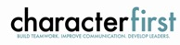
For nearly nine years, we have been inspired by our friendship with Character First. Leaders with this organization provided the wisdom and insight for OK Ethic's Guiding Principles. Go to www.characterfirst.com to learn more about tools to help you integrate character and ethics into your organizational culture, or contact John Burnett at 405-815-0001

Seminar Oct 16: "Coaching & Mentoring at Work"
What if you could make "people development" instead of "people problems" part of your everyday experience? Part of developing your workforce is coaching employees to achieve personal and professional goals—and that benefits the whole organization. This might include enhancing specific business behaviors, managing organizational change, solving complex problems, or correcting specific issues.
Hear Joel Parker, Lyn Watson, and Dr. Nathan Mellor explain how to:
● Make “business coaching” part of your personal leadership style.
● Focus coaching on beliefs and excellence, not just steps of actions.
● Understand high-potential employees and how to lead them to greater success.
● Conduct meaningful coaching experiences using the “C3™ Business Coaching” process.

(This training is designed for mid-level managers and higher. It is recommended for 6 continuing education credits.)
Registration: $395/person for member organizations ($495/person for non-members)
Includes training, materials, and lunch.
Ask about group registrations!
Save $50 if you register by October 5.

Character Council of Central Oklahoma …cultivating good character

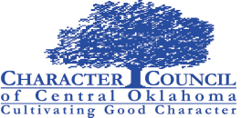
The Character Council of Central Oklahoma is an organization that educates, equips and empowers others to create a culture of good character within Central Oklahoma. Their vision is that Central Oklahoma will become a model community of good character.
Tuesday October 23, 2012 featured speaker:
Scott Pruitt, Oklahoma Attorney General
Cost is $20 per person; Reservations made via luncheon@characterok.org

